|  |
| --- |
| Send Grid Proxy Sequence  Technical Document |
| Version <1.1> |
| **Document Prepared by: Nikhil Bharadwaj Ramashasthri** |

Table of Contents

1. Document Purpose: 3

2. Description: 3

3. Sequence Diagram: 3

4. Implemented workflow: 4

5. Asynchronous Save Email Data: 4

6. Sendgrid API’s: 5

7. Explanation: 7

8. SendGrid Proxy Rest API: 8

9. Conclusion: 9

## Document Purpose:

This document is intended to capture the detail level technical details related to SendGrid Email API proxy technical details along with sequence diagram.

## Description:

SendGrid proxy will capture all the server side bounce backs/ failures with in sendgrid server side request handler, but our any application must fetch bounce backs/ failures and create a report accordingly. To achieve this, we need to set up a proxy layer between our application and SendGrid to fetch bounce backs/ failures.

## Sequence Diagram:

The following is sequential workflow implemented accordingly: 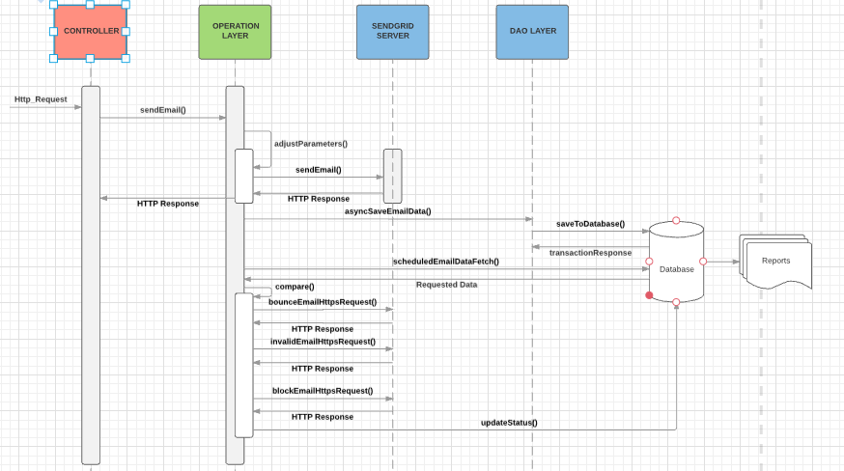

## Asynchronous Save Email Data:

Asynchronous time out call is method helps in making an asynchronous call to sendgrid to check whether the email address was invalid or bounced. The workflow is explained in detail in the following diagram.

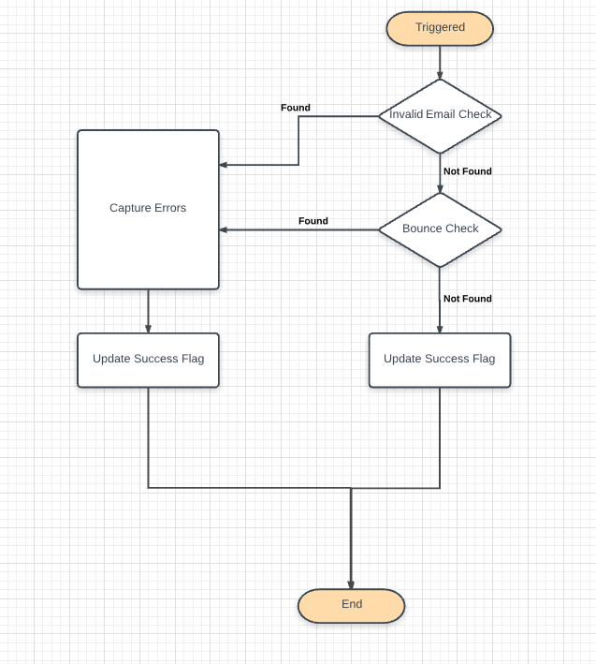

Once the necessary calls have been made we are capturing the errors and updating status flag which can be helpful to update the database for saving the status of the record.

## Sendgrid API’s:

Send Grid is providing following types of call backs which can be used to figure out the bounce backs/ failures/ success status of an email.

**SendGrid Bounces:**

This endpoint allows you to retrieve email bounces. A bounced email is when the message is undeliverable and then returned to the server that sent it. For this we need to make a call with a time out function which will return the below parameters of data:

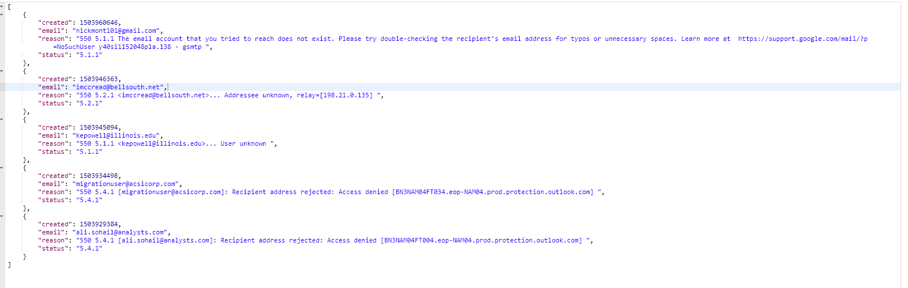

In the above snapshot, response provides parameters like {Created (TimeStamp), Email, Reason, Status (HTTP status)}. We can look for specific invalid email address as well or we can pass timestamp as well.

**Invalid Email’s API:**

This endpoint allows you to retrieve a list of all invalid email addresses. An invalid email occurs when you attempt to send email to an address that is formatted in a manner that does not meet internet email format standards or the email does not exist at the recipient’s mail server.

Examples include addresses without the “@” sign or addresses that include certain special characters and/or spaces. This response can come from our own server or the recipient mail server.

For this we need to make a call with a time out function which will return the below parameters of data:

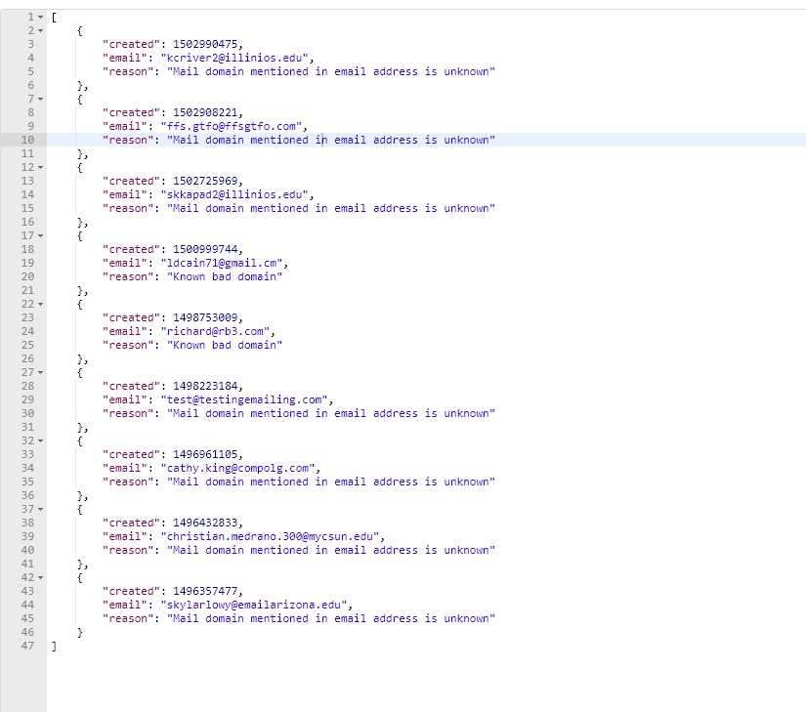

In the above snapshot, response provides parameters like {Created (TimeStamp), Email, Reason}. We can look for specific invalid email address as well or we can pass timestamp as well. Block Email REST API is also.

## Explanation:

The above sequence diagram explains the series of sequential events happen when an email request has been initiated. The following points cover the detail explanation.

* An Email request is initiated from applications will be carried to SendGrid through proxy.
* Once required parameters are in place SendGrid forwards email request to destination servers.
* Any type of response/ exceptions/ errors will be captured by SendGrid.
* SendGrid proxy will make scheduled time out call to above mentioned API’s like bounce API, invalid API by passing the email address which was initiated.
* We will update the captured response along with original message/ data into SendGrid_Proxy_Data table and generate reports as needed with queries.
* SendGrid_Proxy_Data are captured in the following entity snapshot:

|  |  |  |
| --- | --- | --- |
| **COLUMNS** | **DATA TYPE** | **DESCRIPTION** |
| EMAIL_MESSAGE_ID_PK | Varchar | Unique_id from sendgridEmail response |
| EMAIL_SENT_TIMESTAMP | TimeStamp | Captured automatically |
| FROM_EMAIL_ADDRESS | Varchar | Input Parameter |
| TO_EMAIL_ADDRESS | Varchar | Input Parameter |
| CC_EMAIL_ADDRESS | Varchar | Input Parameter |
| EMAIL_SUBJECT | Varchar | Input Parameter |
| EMAIL_CONTENT_TYPE | Varchar | Input Parameter |
| EMAIL_BODY | CLOB | Input Parameter |
| EMAIL_CATEGORY | Varchar | Input Parameter |
| EMAIL_CREATED_AT | Number | Email sent timestamp of sendgrid |
| EMAIL_STATUS | Varchar | Updated through responses |
| EMAIL_FAIL_REASON | Varchar | Updated through responses |
| CHECK_FLAG | Boolean | Differentiate check functionality. |

To map the data and pass between layers we are using a value object “SendGridProxyVO.java” with variables related to business object.

## SendGrid Proxy Rest API:

This exposed Rest API will send an email through above workflow.

REST URL: http://host:port/proxy/sendEmail

Accepts: Content- type application/json

Method: POST

Detail documentation is existing in POSTMAN documentation in the following link.

<https://documenter.getpostman.com/view/1157478/sendgrid_proxy/7156uiQ>

## Conclusion:

The above workflow and explained functionality helps to setup SendGrid Proxy with easy tracking and generate reports alongside with database storage.